

# Raid Defence League Marketing Plan

Benji Rea - 19013412

Photo by [Charlota Blunarova](https://unsplash.com/@charlotablunarova?utm_source=unsplash&utm_medium=referral&utm_content=creditCopyText) on [Unsplash](https://unsplash.com/s/photos/neon-arrows?utm_source=unsplash&utm_medium=referral&utm_content=creditCopyText)

Staffordshire University

BSc (Hons) Computer Games Development

Table of Contents

Marketing Overview 3

Marketing Objectives 3

Marketing Goals 3

Marketing Stratagem 3

Marketing Breakdown 4

Game and Features Overview 4

Key Features 4

Competitive Advantages 4

Key Target Audience 4

Game Messaging 4

Current promotional messaging 4

Game messaging goals 5

Messaging Developments and Strategy 5

Strategy Breakdown 5

Distribution Platforms 5

Web Release 5

App Store 6

Google Play Store 6

Pricing and strategy 6

Competitors 6

Online Presence and Assets 7

Web Assets 7

Website 7

Social Media Assets 7

Twitter 8

TikTok 9

Physical Assets 9

Online Reputation Monitoring 10

Social Media Monitoring 10

Forums 10

Community Development and Management 10

Social Media 10

Key influencer Outreach and engagement 11

General Strategy 11

Types of Targeted sites/Influencers 11

Sites/Influencer list 11

Influencer Outreach strategy 11

Press Release 12

Marketing Campaign Measurement 12

Website 12

Social Media 12

Marketing Plan Timetable 13

Estimating Marketing Budgets 13

Media Assets 13

General Media Assets 13

# Marketing Overview

The aim of my marketing plan is to design and research a strategy to enable me to successfully market my tower defence game project through creating a action plan that will allow me to build a fanbase and brand identity.

## Marketing Objectives

My objectives can be split into 4 key categories that I’ve outlined below:

* **Reach** – By focusing on my target audience through build an early following pre-release
* **Action** – Promote user interaction to further extend my reach
* **Conversion** – Convert impressions into views, likes, and comments with the end goal of converting those int downloads and visitors to my website or app store page.
* **Engagement** – Utilise forums such as reddit and my key social media platforms to engage with the communities that poser an interest in the game.

## Marketing Goals

To best value how successful my marketing plan is I intend to compare my performance with these goals:

* Attain a total of 15,000 users during release month.

Engaging a large audience pre-release will enable reaching this goal

* Baseline $0.20 Cost per Install from Targeted Social Media adverts.

Any impressions that do not convert into downloads from paid promotions are bad

* Obtain 50% Release Day retention and 20% Release Weekend

## Marketing Stratagem

My breakdown for the overall marketing plan for my tower defence game will be spit to a further 4 sections

**Foundation** – Researching my target audience and creating simple prototypes of logos and promotional material.

**Awareness** – Start to generate hype about the game, narrow in on key audience and finalise promotional material

**Growth** – Work on targeting key influencers at a large scale, work to convert early audience into dedicated fanbase.

**Expansion** –Target outliers to my original audience, using my preestablished fanbase and data collected from all previous sections

# Marketing Breakdown

## Game and Features Overview

Release Date: Jan 2021

Platform: Web – Jan 2021 (Mobile - iOS/Android – Spring 2021)

Genre: Casual Strategy

Cost: Freemium, Game is free to install but payment required to remove advertising

### Key Features

* Calm playstyle
* Unique low-poly style

### Competitive Advantages

* Waves are quicker than other games in the genre.
* Less complex than other games in the genre such as Bloons

# Key Target Audience

Age Range:12-24+

Generational Types: Gen Z

Countries: US, UK/Europe

Main Geological focus: North American and Western Europe regions

Language Support: English

# Game Messaging

**Foundation Stage**

## Current promotional messaging

Short Version:

* Ready your defences to repel the police and make your escape

Ideal for using on the app store and short promo material.

Long Version:

* Time is running out in as your perfect heist spirals into a chaotic stand-off. The police have deployed recon drones into the ventilation system and its down to you, the crew’s cyber-hacker, to fend them off while you finish your escape!

Ideal for the app store description and the website

## Game messaging goals

* Uniform messaging across all platforms.
* Convert impressions to downloads.

# Messaging Developments and Strategy

**Foundation Stage**

When designing any new messaging I will research and take influence from existing games within the genre like Elements TD2 and Bloons Tower Defence 5 so I can create the most

Furthermore, key traits can be isolated that will make my messaging unique without putting off my key audience

It is vital that my messaging has a clear call to action such as sharing content or downloading the game.

# Strategy Breakdown

## Distribution Platforms

**Foundation Stage**

### Web Release

Using the website enables me to distribute onto all devices running windows or macOS.

Web Goals

* Produce a clearly laid out website that is easy to navigate
* Make sure messaging is consistent across all platforms
* Create short preview/trailer which concisely demonstrates core features.
* Use search engine optimisation to increase traffic.

### App Store

Using the app store enables me to distribute onto all devices running the latest iOS build.

App Store Goals

* Produce a clearly laid out product page that entices the user
* Design a simplistic icon that is easily recognisable on the store and device
* Make sure messaging is consistent.
* Create app preview which concisely demonstrates core features.
* Use optimal buzz phrases to improve discoverability in search.

### Google Play Store

Using the Google Play Store enables me to distribute onto all devices running the latest android build.

Google Play Store Page Goals

* Use robust creative promotional material in line with existing messaging.
* Provide a concise representation of the game.
* Provide precise tagging to support the game in being promoted correctly.

Justification for selecting these platforms

* Web offers the largest user base possible.
* Offers a good range of users across multiple devices.

## Pricing and strategy

The game is free to install with the possibility to remove advertisements for a one-time fee of USD$0.99 on mobile. The web version will be a reduced version of the game with simple banner ads.

This is because free to install games have a significant higher success rate as users are willing to download it to see if they’ll enjoy it before upgrading to Ad-Free.

Advertisements will be the main avenue for generating money, as many users can become frustrated with adverts and will pay to remove them.

### Competitors

Bloons Tower Defence 6: £4.99

Element Tower Defence 2: Early Access £7.99

Tactical War: Tower Defence: Costs £0.99 to remove ads

# Online Presence and Assets

The aim of this section is to detail the online presence and brand identity of the game.

## Web Assets

**Foundation Stage**

### Website

The splash for Raid Defence League will be the first interaction many potential players see the game and is the crucial moment of conversion from impression to download.

Current website features

* Consistent Game titling with tagline
* Social media placeholders
* Link to second page with previews and screenshots

Website future

* Simple Search engine optimisation (SEO)
* Set up google analytics or equivalent for data collection.

Current layout

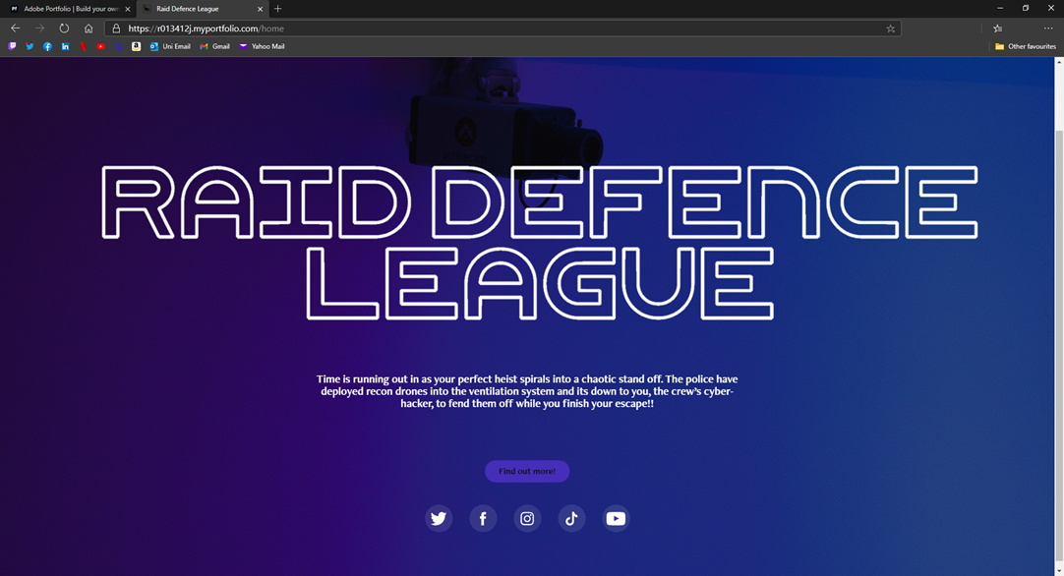

## Social Media Assets

**Foundation Stage**

### Twitter

Utilising Twitter will allow me to post early content to my target audience contain sneak peaks and exclusive content, combined with heavy use of correct hashtags I can greatly increase my reach.

Twitter suggestions

* Engage with a list of influences including YouTube content creators and twitch streamers
* Make use of twitters default analytics to customise content

Example Tweets

### TikTok

Utilising apps like TikTok and Snapchat enables be to post short snippets of gameplay or features even if they’re not finished while still being able to promote the game and interact with fans

TikTok suggestions

* Create a development series where I follow a similar format posting dev logs or answering questions
* Upload short snippets of unpolished gameplay to receive early feedback and generate buzz.

## Physical Assets

Although some people might consider them dated, I believe physical assets such as posters can be important if attending conference or to giveaway to fans!

An example of a prototype design could look like this.

# 

# Online Reputation Monitoring

**Awareness Stage**

Through monitoring analysing the online reputation of my game I will be able to ascertain the general opinion of the game and how the community shaping around it are feeling about different aspects

### Social Media Monitoring

Monitoring who engages with tweets and TikToks will be imperative to gauging early user opinions and is the first opportunity to receive criticism

### Forums

Looking at things like reddit and games development I will be able to gauge more professional opinions of the game.

# Community Development and Management

Developing a community and then managing that to maintain a positive and safe space will be one of the hardest challenges of this entire plan.

## Social Media

Having a consistent social media presence is integral to building a community around the game

Social Media Goals

Posting and Community Engagement

* As much shareable content as possible
* Consistently posting on TikTok with an even split between gameplay & development
* Consistently posting on Twitter with a heavy presence on development
* Immediately Share and promote any mainstream press coverage
* Proper use of hashtags and trends to try extending reach

Monitoring

* Look at monitoring any trends relating to the game and the industry such as other games in the genre.

Discussions

* Make sure to engage with all comments and reviews in a timely and positive manner where possible.
* Respond fairly to negative comments and criticisms.

# Key influencer Outreach and engagement

## General Strategy

**Growth Stage**

This section is to analyse the influencers I will attempt to engage and enlist in the marketing and promotion of the game

### Types of Targeted sites/Influencers

* Mobile Game Reviewers
* Gaming Related Bloggers/Vloggers
* Youtubers and Twitch Streamers

### Sites/Influencer list

* edamame.reviews
* Twitch: TheFuzzyMole
* Twitch: 8BitCannonFodder
* Youtuber: NerdCubed

### Influencer Outreach strategy

* Direct
  + Find Business Email
  + Direct message on social media platform
* Indirect
  + Hashtags and @’s on social media
  + Managed influencer campaigns

# Press Release

**Growth Stage**

To grow the audience effectively I can create scripted press released for websites like gamespress.com and gamesindustry.biz that spread information about the game

Basic Outline

* Headline
  + “New Epic Tower Defence Game Live Now!”
* Dateline
* Sub headline
  + The long-awaited Raid Defence League is out today!
* Description
  + “Raid Defence League is a free to play tower defence game available web, defend your heist crew from the police virus incursion to pull off the greatest heist of all time!”
* Call To action
  + “Join now before it’s too late!”
* Assets
  + Gameplay Video, Trailer, Teaser Images
* Contact Info
  + Twitter account and website

# Marketing Campaign Measurement

I’ve identified key marketing goals to achieve with each target platform

## Website

* Increase to all site traffic of 10%

## Social Media

Twitter

* Follower count increases by 20% overall
* 7/10 tweets have replies or retweets
* All Tweets have a 50% engagement percentage

TikTok

* Follower count increases by 20% overall
* All Videos have a 70% engagement percentage

# Marketing Plan Timetable

Below is a prototype Gantt chart for different strategies and their implementation dates.

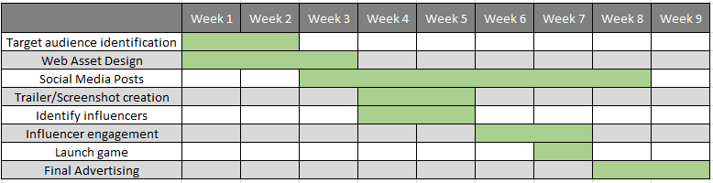

# Estimating Marketing Budgets

These are the estimated costs for producing marketing materials.

|  |  |  |  |
| --- | --- | --- | --- |
| **Advertising Channel** | **Priority** | **Type** | **Budget** |
| Event Posters | MED | Promotional Materials | £12.99 |
|  |  | **Total:** | £12.99 |

# Media Assets

This is the basic media assets I will need to produce for the marketing to be successful.

### General Media Assets

* Trailer
* Game Logo
* Gameplay screenshots and GIFS
* Dev Log Videos